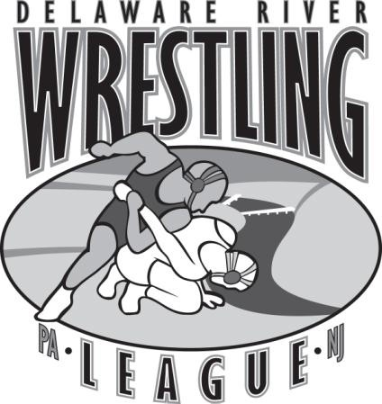

Delaware River Wrestling League (DRWL)

Certified Officials Voucher

Officials Name:
Driver’s License/State #:

Home Address:

Match Date:

Opponents: vs. vs.

Match Location:

Match Hours (Round to nearest ½ hour):

Certified Officials Fee Schedule: $ 40.00 per hour ($120.00 maximum total fee)

Official’s Signature

Coach’s Signature

Send Voucher to:

Lauren Bartlett
DRWL Treasurer
611 Scotch Road
Pennington, NJ 08534

